**Lab Assignment-8**

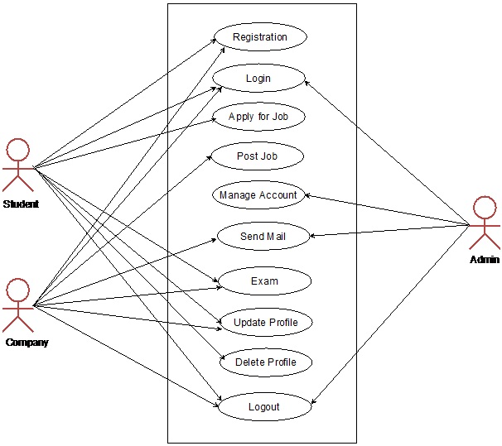

Some scenarios of the system are as follows :

Scenario 1: Student Registration

Alex, a final-year student, logs into the campus placement system to register for the upcoming placement season. He provides necessary details such as personal information, academic records, and a comprehensive resume. The system validates the information and generates a unique student ID for Alex.

Scenario 2: Job Posting by Companies

XYZ Company wants to participate in the campus placements. The HR representative logs into the system, posts job openings, and specifies the eligibility criteria, job roles, and other relevant details. The system then notifies registered students who match the criteria, ensuring they are aware of the job opportunities.

Scenario 3: Application Submission

Emily, a student interested in a position at XYZ Company, reviews the job details and decides to apply. She submits her application through the campus placement system, attaching her resume and any other required documents. The system confirms the successful submission and updates Emily on the status of her application.

Scenario 4: Shortlisting and Interview Scheduling

Upon receiving applications, XYZ Company reviews them through the system. The company shortlists candidates based on specified criteria, and the system automatically sends interview invitations to the selected students. It also provides a schedule with interview details, allowing students to confirm or reschedule as needed.